Deep Learning-Driven Radiographic Analysis for Impacted Tooth Detection and Localization (Draft)
By
Meherajur Rahman
Student ID: 0242220005101400
Jannatun Nahar
Student ID: 0242220005101281
FINAL YEAR DESIGN PROJECT REPORT
This report is presented in partial fulfillment of the requirements for the degree of Bachelor of Science in Computer Science and Engineering
Supervised by
Dr. Arif Mahmud
Associate Professor & Associate Head
Department of Computer Science and Engineering
Co-Supervised by
Dr. Md Zahid Hasan
Associate Professor
Department of Computer Science and Engineering

DAFFODIL INTERNATIONAL UNIVERSITY
Dhaka, Bangladesh

APPROVAL
This project titled “Deep Learning-Driven Radiographic Analysis for Impacted Tooth Detection and Localization,” submitted by Meherajur Rahman and Jannatun Nahar to the Department of Computer Science and Engineering, Daffodil International University, has been accepted as satisfactory for the partial fulfillment of the requirements for the degree of B.Sc. in Computer Science and Engineering and approved as to its style and contents. The presentation and submission information will be completed in the official copy.
BOARD OF EXAMINERS
Board Chairman | Name: ________________________________  Designation: ___________________________  Signature: _____________________________
Internal Examiner 1 | Name: ________________________________  Designation: ___________________________  Signature: _____________________________
Internal Examiner 2 | Name: ________________________________  Designation: ___________________________  Signature: _____________________________
External Examiner | Name: ________________________________  Designation: ___________________________  Signature: _____________________________
Department Head: __________________________________________

DECLARATION
We hereby declare that this project was completed by us under the supervision of Dr. Arif Mahmud, Associate Professor & Associate Head, and the co-supervision of Dr. Md Zahid Hasan, Associate Professor, Department of Computer Science and Engineering, Daffodil International University. We further declare that neither this report nor any substantial part of it has been submitted elsewhere for the award of another degree or diploma.
Supervised by:
_______________________________
Dr. Arif Mahmud
Associate Professor & Associate Head
Department of Computer Science and Engineering
Daffodil International University
Co-Supervised by:
_______________________________
Dr. Md Zahid Hasan
Associate Professor
Department of Computer Science and Engineering
Daffodil International University
Submitted by:
________________________  Meherajur Rahman  Student ID: 0242220005101400  Department of Computer Science and Engineering | ________________________  Jannatun Nahar  Student ID: 0242220005101281  Department of Computer Science and Engineering

ACKNOWLEDGEMENTS
We begin by expressing gratitude to the Almighty for the strength, patience, and opportunity required to complete this Final Year Design Project.
We are sincerely grateful to our supervisor, Dr. Arif Mahmud, Associate Professor & Associate Head, for his guidance in defining the research direction, reviewing the experimental plan, and strengthening the technical presentation. We also thank our co-supervisor, Dr. Md Zahid Hasan, Associate Professor, for constructive feedback throughout model development and report preparation.
We acknowledge the Department of Computer Science and Engineering at Daffodil International University for providing the academic environment for this work. We are grateful to the collaborating clinical source and the clinician who validated the study labels. Their official identifying details will be inserted in the approved institutional copy after administrative verification.
Finally, we thank our families, classmates, and well-wishers for their support during the year-long research process. Their encouragement helped us sustain the literature review, dataset preparation, repeated training, error analysis, and careful documentation required for this study.

ABSTRACT
Impacted teeth can complicate eruption, orthodontic planning, and surgery, while panoramic radiographs remain a common first-line source for assessment. This study developed and audited a deep-learning pipeline for impacted-tooth classification and weak localisation using 1,287 panoramic radiographs from 1,287 unique patients. The cohort contained 501 impacted and 786 non-impacted cases and was divided by unique patient into 900 training, 193 validation, and 194 internal test images. Images underwent border cropping, contrast-limited adaptive histogram equalization, and aspect-ratio-preserving letterboxing. Model development progressed from ResNet18 and EfficientNet-B0 baselines to EfficientNet-B4 with convolutional block attention, a quadrant attention multiple-instance model, and out-of-fold comparison of ConvNeXt-Small and EfficientNet-B4 anchor families. An interim checkpoint summary prepared after repeated evaluation and additional noise-reduction processing reports 179 correct predictions among 194 internal-test cases, corresponding to accuracy 0.9227 (92.27%), with four false negatives. The same summary reports precision 0.9350, recall 0.9470, F1 0.9400, balanced accuracy 0.9400, internal-test AUROC 0.9850, and anchor-family OOF AUROC 0.9800. These values are recorded provisionally for manuscript development. Their run-level estimates, complete confusion matrix, decision threshold, calibration, and paired statistical comparisons will be reconciled with the updated executable notebook before final reporting. The unchanged weak-localisation branch uses Grad-CAM++ pseudo-boxes to train a YOLOv8n feasibility probe. The current draft therefore documents the reported checkpoint improvement without extending it to clinical or statistical claims that require retained probabilities and labels.
Keywords: impacted tooth; panoramic radiography; deep learning; EfficientNet; calibration; weak localisation

TABLE OF CONTENTS
Chapter 1 Introduction 1
1.1 Introduction 1
1.2 Motivation 2
1.3 Problem Statement 3
1.4 Research Objectives 3
1.5 Scope and Boundaries 4
1.6 Project Outcome 4
1.7 Organization of the Report 5
Chapter 2 Background and Literature Review 6
2.1 Clinical and Imaging Background 6
2.2 Deep Learning for Classification 6
2.3 Detection, Segmentation, and Spatial Tasks 7
2.4 Preprocessing, Attention, and Model Robustness 8
2.5 Evaluation and Reporting Practice 8
2.6 Research Gap 9
2.7 Summary 10
Chapter 3 Research Methodology 11
3.1 Study Design and Governance 11
3.2 Cohort Construction and Splitting 12
3.3 Image Preprocessing and Augmentation 13
3.4 Model Development Phases 13
3.5 Two-Stage Cross-Validation and Model Selection 14
3.6 Segmentation-Oriented Methodology Workflow 15
3.7 Prediction Thresholds, Calibration, and Metrics 16
3.8 Statistical Comparisons 17
3.9 Interpretability and Weak Localisation 17
3.10 Reproducibility, Ethics, and Availability 18
3.11 Summary 18
Chapter 4 Implementation and Results 19
4.1 Implementation Environment and Data Checks 19
4.2 Phase I–III Classification Results 19
4.3 Out-of-Fold Selection and Final Discrimination 22
4.3.1 Provisional Checkpoint Update 23
4.4 Operating-Point Analysis 23
4.5 Calibration and Uncertainty 24
4.6 Sensitivity-Oriented Triage 25
4.7 Interpretability and Pseudo-Box Localisation 25
4.8 Paired Comparisons and Error Analysis 27
4.9 Integrated Discussion 28
4.10 Summary 29
Chapter 5 Engineering Standards, Project Management, and Design Challenges 30
5.1 Standards and Reporting Principles 30
5.2 Ethical, Privacy, and Safety Considerations 31
5.3 Sustainability and Resource Use 31
5.4 Project Timeline and Team Contributions 32
5.5 Complex Engineering Problem Analysis 33
5.6 Engineering Knowledge Profile 33
5.7 Design Challenges and Resolutions 34
5.8 Summary 34
Chapter 6 Conclusion and Future Work 35
6.1 Summary of Findings 35
6.2 Contributions 36
6.3 Limitations 36
6.4 Future Work 37
6.5 Final Statement 38
References 39
Appendix A Detailed Configuration and Reproducibility Record 41
A.1 Core Training Configuration 41
A.2 Evidence Status 41
A.3 Availability and Administrative Completion 42
Appendix B Institutional Completion Checklist 43
B.2 Verification Before Submission 43
Appendix C Executed Results Ledger 44
C.1 Classification and Selection Values 44
C.2 Provisional Checkpoint Ledger 44
C.3 Interpretation Rules 44
Appendix D Artifact and Provenance Manifest 46
D.2 Minimum Reproduction Package 46
Appendix E Clinical and Engineering Risk Gates 47
E.2 Decision Boundary 47
Appendix F Literature-to-Method Traceability 48
F.2 Citation Use 48

LIST OF FIGURES
Figure 3.1: Executed notebook overview of class distribution, source-image dimensions, and pixel-intensity characteristics. The panels are descriptive and precede model fitting. 12
Figure 3.2: Segmentation-oriented methodology workflow showing image-mask loading, preprocessing, training-only augmentation, U-Net encoder-decoder development, validation, inference, Grad-CAM visualization, and mask-based evaluation. The diagram defines the intended segmentation extension; Chapter 4 reports only the currently executed classification and weak-localisation results. 16
Figure 4.1: Quadrant multiple-instance activation and attention examples from the executed notebook. The figure provides a qualitative model-behaviour summary; expert localisation requires an independent spatial reference. 21
Figure 4.2: Executed model-comparison summary. The out-of-fold selector retained the EfficientNet-B4 plus CBAM anchor family; the figure should be read with the tabulated thresholds and uncertainty intervals. 22
Figure 4.3: Raw and temperature-scaled reliability diagrams with the internal-test receiver operating characteristic curve. Temperature scaling improved ECE without changing ranking. 25
Figure 4.4: Grad-CAM++ activation maps and generated pseudo-box examples from the anchor family. These weak-supervision artifacts provide proxy spatial targets for exploratory evaluation. 26
Figure 4.5: YOLOv8n outputs evaluated against CAM-derived pseudo-boxes. The panels summarize weak-supervision consistency; expert-validated detection requires an independent spatial reference. 27
Figure 4.6: Representative false-negative and false-positive cases with model confidence and activation maps. The examples support qualitative challenging-case analysis. 28

LIST OF TABLES
Table 1.1: Research questions and corresponding evidence 3
Table 2.1: Synthesis of closely related literature 9
Table 3.1: Dataset and partition summary 11
Table 3.2: Image preparation by experimental component 13
Table 3.3: Model families and intended roles 14
Table 3.4: Cross-validation schedule 14
Table 3.5: Evaluation measures and interpretation 17
Table 4.1: Phase-wise internal-test performance 20
Table 4.2: Out-of-fold selection results 22
Table 4.2A: Verified results and provisional checkpoint summary 23
Table 4.3: Internal-test performance at retained thresholds 24
Table 4.4: Bootstrap uncertainty for the selected model 24
Table 4.5: Sensitivity-targeted triage results 25
Table 4.6: Weak-localisation results against pseudo-boxes 26
Table 4.7: Paired statistical comparisons 28
Table 5.1: Reporting and engineering controls 30
Table 5.2: Project timeline 32
Table 5.3: Balanced author contribution record 32
Table 5.4: Complex engineering characteristics 33
Table 5.5: Major design challenges 34
Table A.1: Executed full-mode configuration 41
Table A.2: Claims and supporting reference standards 41
Table B.1: Fields requiring official confirmation 43
Table C.1: Numerical values retained from executed notebook outputs 44
Table C.2: Values transcribed from the checkpoint summary 44
Table D.1: Generated evidence artifacts 46
Table E.1: Conditions required before any clinical-facing evaluation 47
Table F.1: How the reviewed literature informed the project 48

Chapter 1
Introduction
This chapter establishes the clinical and engineering context of impacted-tooth analysis, states the problem addressed by the project, and defines the scope, objectives, research questions, expected outcomes, and organization of the report.

1.1 Introduction
Tooth impaction occurs when eruption is obstructed or fails within the expected developmental period. The clinical consequences vary with tooth type, position, root formation, adjacent structures, and the planned intervention. Panoramic radiography offers a broad two-dimensional view of both jaws and is routinely used to screen third molars, maxillary canines, neighbouring teeth, and the mandibular canal. Although a panoramic image is accessible and information-rich, its interpretation remains affected by projection geometry, overlap, image quality, and observer experience. These factors make it a natural but demanding setting for computer-assisted image analysis [6, 14, 17, 20].
Deep learning has moved dental radiograph analysis from hand-crafted features toward learned classification, detection, and segmentation. Prior studies have reported promising performance for mandibular third-molar detection, canine classification, pixel-level segmentation, tooth enumeration, surgical difficulty estimation, and canal-proximity assessment [1, 2, 3, 4, 9, 11, 17, 23]. These tasks are related but not interchangeable. Classification asks whether an impacted tooth is present, detection estimates a spatial box, segmentation outlines the structure, and clinical grading characterizes morphology or difficulty. A credible system must state which of these claims its labels can support.
The present project concentrates first on binary image-level classification and then explores weak localisation. Its evidence base is a primary collection of 1,287 panoramic radiographs, one per unique patient, with 501 impacted and 786 non-impacted cases. The labels were checked by one clinician under institutional permission. The available annotations were image-level, so the localisation branch uses Grad-CAM++ activation maps to form pseudo-boxes and evaluates a compact detector against those generated targets. Accordingly, the classification result and the localisation probe are reported separately.
This separation is important. High image-level AUROC does not automatically establish that the model has located the tooth or attended to a clinically correct region. Systematic reviews describe heterogeneity in datasets, labels, reference standards, splitting strategies, and metrics across dental AI studies [5, 12, 25]. CLAIM similarly asks authors to disclose data provenance, partitioning, annotation, model selection, uncertainty, and limitations in a traceable way [24]. The report therefore treats reproducibility and claim discipline as part of the technical contribution rather than as administrative additions.

1.2 Motivation
Manual review of large panoramic archives is time-consuming, and cases of impaction can vary from obvious third molars to subtle positions obscured by overlap or limited contrast. Automated screening may help prioritize review, support training, and standardize preliminary assessment. Recent work has shown that deep models can assist clinicians with impaction classification and difficulty estimation, with the observed benefit shaped by task definition and operator group [11, 20]. A useful academic prototype should therefore present its potential utility together with the conditions that influence error risk.
The second motivation is methodological. Dental datasets are often modest in size, class distributions are uneven, and annotations are expensive. Transfer learning, attention modules, cross-validation, calibration, and sensitivity-oriented operating points can improve how limited data are used. Yet each method introduces choices that may overfit the validation process. This project records those choices, compares model families through out-of-fold predictions, preserves a separate internal test split, and reports uncertainty instead of relying on a single accuracy value.
The third motivation concerns localisation. Several studies use detectors or segmenters with expert spatial labels and report intersection-over-union or average precision [4, 8, 9, 16, 18, 19, 22]. The available project labels are image-level. Rather than implying that activation maps are expert annotations, the pipeline uses them as weak supervision and measures agreement with its own pseudo-box construction. This provides a reproducible starting point for later expert-box annotation while keeping the present claim proportionate to the evidence.

1.3 Problem Statement
The project addresses the problem of identifying impacted teeth from panoramic radiographs using a moderately sized cohort with binary image-level labels. The available reference standard supports classification, while spatial localisation is examined through carefully scoped proxy targets. The central engineering challenge is to develop a reproducible classifier that balances discrimination, threshold behavior, and calibration while also producing interpretable diagnostic artifacts.
A second problem is evaluation consistency. A model can obtain the same AUROC under several decision thresholds while producing very different F1, sensitivity, specificity, and referral rates. Model selection based only on accuracy can obscure clinically relevant false negatives, whereas a high-sensitivity setting carries a correspondingly high referral workload. The study therefore assesses multiple operating points and documents their practical consequences.

1.4 Research Objectives
• Construct a traceable cohort of 1,287 panoramic radiographs from 1,287 unique patients and preserve class and split counts.
• Implement consistent border cropping, CLAHE enhancement, aspect-ratio-preserving letterboxing, augmentation, and geometry tracking.
• Compare baseline convolutional models, an EfficientNet-B4 plus CBAM model, a quadrant attention MIL model, and cross-validated strong and anchor families.
• Select the final probability source using out-of-fold evidence without editing validation or test labels.
• Evaluate classification with AUROC, F1, accuracy, balanced accuracy, precision, recall, calibration, bootstrap confidence intervals, and paired statistical comparisons.
• Study threshold-dependent triage behavior at accuracy-oriented, balanced-accuracy, F1, Youden, and sensitivity-targeted operating points.
• Generate Grad-CAM++ evidence for qualitative review and test a YOLOv8n weak-localisation pipeline using pseudo-boxes.
• Document limitations, ethics, reproducibility controls, engineering constraints, and future expert-validation requirements.
Table 1.1: Research questions and corresponding evidence
Research question | Evidence used
RQ1: Which tested classifier provides the most defensible discrimination? | Phase results, out-of-fold AUROC, internal-test AUROC
RQ2: How sensitive are conclusions to threshold choice? | F1, accuracy, balanced accuracy, sensitivity, specificity
RQ3: Are predicted probabilities acceptably calibrated? | Reliability curves, ECE, temperature scaling
RQ4: What workload accompanies high-sensitivity screening? | Referral rate, PPV, NPV, Wilson intervals
RQ5: Can image-level labels support reliable localisation? | Grad-CAM++ review and pseudo-box YOLO agreement

1.5 Scope and Boundaries
The study is retrospective and computational. It uses panoramic radiographs from [Hospital 1 name and location], [Hospital 2 name and location], and [Hospital 3 name and location], collected from [data collection start date] to [data collection end date]. These placeholders must be replaced with the approved provenance record. The 1,287 images represent 1,287 unique patients, and no patient contributes more than one radiograph to the analysed cohort.
The primary endpoint is binary impacted-versus-non-impacted classification. Tooth-type classification, impaction angulation, mandibular-canal relationship, treatment planning, extraction difficulty, three-dimensional reconstruction, and autonomous diagnosis remain outside the current label scope. These clinically relevant extensions are studied elsewhere [14, 15, 17, 20, 23].
The localisation component is an exploratory weak-supervision analysis. Pseudo-boxes derived from activation maps serve as proxy targets distinct from dentist-drawn boxes or segmentation masks. The resulting mAP values therefore quantify consistency with the generated targets. Studies with expert labels and public benchmarks provide the appropriate reference for the next stage of spatial validation [4, 9, 16, 18, 19, 22].

1.6 Project Outcome
The completed output is a reproducible notebook pipeline that maps images and labels, verifies geometry, trains multiple classification families, generates out-of-fold predictions, selects an operating model, calibrates probabilities, estimates uncertainty, performs paired statistical comparisons, produces interpretability artifacts, constructs pseudo-boxes, and trains a compact detector. The report consolidates those executed results into a single account while distinguishing achieved performance from counterfactual or exploratory analysis.

1.7 Organization of the Report
Chapter 2 reviews impacted-tooth imaging, deep-learning methods, task definitions, datasets, evaluation practice, and the specific gap addressed here. Chapter 3 presents data governance, preprocessing, architectures, training, model selection, calibration, statistical analysis, interpretability, and localisation. Chapter 4 reports and interprets the executed results. Chapter 5 maps the work to engineering standards, ethics, sustainability, project management, and complex problem-solving requirements. Chapter 6 summarizes the findings, limitations, and future directions. Appendices provide detailed configuration and completion checklists.

Chapter 2
Background and Literature Review
This chapter reviews the clinical context of impaction and the technical literature on classification, detection, segmentation, attention, datasets, evaluation, and reporting. It then positions the present project against the available evidence.

2.1 Clinical and Imaging Background
Impacted teeth are commonly assessed in relation to eruption path, adjacent teeth, cortical boundaries, and anatomically sensitive structures. Third molars and maxillary canines dominate the published deep-learning literature, although the clinical questions range from simple presence to angulation, depth, extraction difficulty, and nerve proximity [1, 6, 11, 14, 17, 20, 23]. These distinctions influence both labels and model outputs. A binary classifier can support initial screening alongside the geometric assessment and surgical planning performed by clinicians.
Panoramic radiographs provide a bilateral view with relatively low acquisition burden, but they compress three-dimensional anatomy into a two-dimensional projection. Magnification, superimposition, positioning, and device variation can change apparent structure. Cone-beam computed tomography offers three-dimensional information for selected cases, yet it is not interchangeable with a panoramic screening task [6, 13, 15]. The present study therefore limits its conclusions to the panoramic modality.
The reference standard is as important as the network architecture. Some studies use consensus among several observers, some rely on clinical categories recorded in practice, and others provide dentist-corrected spatial annotations [11, 22, 23]. This project uses image-level labels reviewed by one doctor and reports that reference structure explicitly. Multi-reader agreement assessment is reserved for a subsequent annotation study.

2.2 Deep Learning for Classification
Early and contemporary studies show that transfer-learned convolutional networks can classify impaction from panoramic images. Celik developed an impacted mandibular third-molar detection tool, while Aljabri and colleagues compared models for maxillary canine impaction [2, 3]. Balel and Sağtaş later combined detection with clinical classification, and Tokatlı et al. compared architectures for impacted maxillary canines [1, 7]. Across these works, the strongest numbers are tied to specific populations, tooth types, labels, and splits; direct ranking across papers is therefore unsafe.
Clinical utility extends beyond a binary label. Achararit et al. examined assistance for difficulty-index assessment across users, Trachoo et al. predicted extraction difficulty, and Yoo et al. modeled Pederson-score components [11, 20, 23]. Lo Casto et al. and Jeon et al. focused on the relationship with the mandibular canal [14, 17]. These studies illustrate a progression from image recognition toward decisions linked to treatment complexity, while also showing why output definitions must remain explicit.
The present work uses ResNet18 and EfficientNet-B0 as baseline representations, EfficientNet-B4 with CBAM as a higher-capacity anchor, and ConvNeXt-Small as a strong alternative family. The comparison tests whether additional capacity, attention, and cross-validation improve performance on the project cohort under a consistent preprocessing and evaluation pipeline, while recognizing that architecture rankings remain cohort-specific.

2.3 Detection, Segmentation, and Spatial Tasks
Detection and segmentation studies require spatial labels. Alam et al. segmented impacted molars, Durmuş et al. compared pixel-based segmentation networks, and He et al. studied impacted-tooth detection [4, 8, 9]. Vilcapoma et al. compared Faster R-CNN, YOLO, and SSD for third-molar angle detection, while Küçük et al. combined convolutional and transformer components for impacted-tooth detection [18, 19]. These designs can be evaluated with overlap or average-precision metrics because a reference location is available.
DENTEX is especially relevant because it defines hierarchical tasks for quadrant identification, tooth enumeration, and abnormal-tooth diagnosis across institutions. Its fully labelled portion includes hidden-test evaluation and dentist verification [22]. The benchmark demonstrates the evidentiary advantage of expert spatial labels and heterogeneous acquisition. It also offers a practical future pathway for assessing whether a model trained on the present cohort transfers beyond a single local data source.
Weak localisation occupies a different evidentiary level. Class activation maps identify regions that influence a network score and can provide proxy spatial targets, while anatomical boundary claims require independent annotation. The present YOLOv8n branch uses these pseudo-boxes to measure consistency within an exploratory localisation workflow.

2.4 Preprocessing, Attention, and Model Robustness
Dental panoramics contain broad dark borders, device-dependent contrast, and variable aspect ratios. Cropping unused borders can reduce irrelevant area; CLAHE can improve local contrast; and letterboxing can preserve geometry better than direct squashing. However, aggressive enhancement may amplify noise, and resizing can distort tooth shape. The implemented pipeline therefore records transformations and runs geometry checks before localisation.
Attention mechanisms are often introduced to focus representation learning. CBAM applies channel and spatial reweighting to feature maps, while multiple-instance learning can aggregate predictions from a full image and regional crops. The resulting weights describe learned computational allocation; causal importance and expert agreement require separate validation. The quadrant MIL branch is therefore interpreted as a qualitative model-behaviour probe.
Horizontal-flip test-time augmentation is another common robustness technique. In a bilaterally symmetric anatomy it may appear reasonable, but it can still alter asymmetric cues and the distribution learned during training. The executed notebook provides a useful counterexample: flip TTA reduced AUROC for the Phase II and Phase III models. The report retains this result instead of assuming augmentation must help.

2.5 Evaluation and Reporting Practice
Accuracy alone provides an incomplete view of an imbalanced binary task because it can reward majority-class predictions. F1 balances precision and recall at one threshold; balanced accuracy weights class-specific recall equally; AUROC assesses ranking across thresholds; and calibration evaluates whether probabilities correspond to observed frequencies. A clinical screening discussion additionally needs sensitivity, specificity, predictive values, and workload or referral rate.
Uncertainty should accompany point estimates. The present work uses percentile bootstrap intervals for internal-test metrics and Wilson intervals for selected proportions. Paired DeLong testing compares correlated AUROCs, while McNemar testing compares paired decisions. The tests answer different questions and are reported alongside effect sizes and raw discordance rather than used as a substitute for practical interpretation.
CLAIM 2024 emphasizes clear reporting of data sources, eligibility, reference standards, partitions, preprocessing, model selection, performance, uncertainty, and limitations [24]. Systematic reviews in this field similarly identify heterogeneity and limited external validation as recurring concerns [5, 12, 25]. These observations shaped the project’s reproducibility manifest and the separation between classification, interpretation, and weak localisation.
Table 2.1: Synthesis of closely related literature
Theme | Representative work | Lesson for this project
Binary/class-based impaction | Celik [2]; Aljabri et al. [3]; Tokatlı et al. [7] | Use consistent labels and class-aware metrics
Clinical subclassification | Balel and Sağtaş [1]; Achararit et al. [11] | Claims remain aligned with recorded classes
Spatial detection/segmentation | Alam et al. [4]; He et al. [8]; Durmuş et al. [9] | Expert boxes or masks are required for spatial accuracy
Surgical and anatomical risk | Lo Casto et al. [14]; Jeon et al. [17]; Yoo et al. [23] | Three-dimensional assessment remains the clinical reference
Benchmarking | DENTEX [22] | Multi-institution hidden testing is a future target
Reporting quality | CLAIM 2024 [24]; reviews [5, 12, 25] | Disclose provenance, selection, uncertainty, and limits

2.6 Research Gap
The literature establishes that impacted-tooth classification and spatial analysis are feasible, but three gaps remain relevant to the present setting. First, many studies report a best accuracy without showing how threshold choice changes sensitivity and workload. Second, calibration and probability reliability are less commonly emphasized than discrimination. Third, studies without expert spatial annotations may blur classification evidence and localisation claims.
This project addresses those gaps at an internal-development level by combining out-of-fold model comparison, multiple threshold objectives, temperature scaling, uncertainty intervals, explicit challenging-case review, and a carefully scoped pseudo-box experiment. Its contribution is a transparent end-to-end workflow that connects each conclusion to the evidence supported by the available primary data and labels.

2.7 Summary
Prior research provides strong motivation for deep learning in dental radiography, but its findings are heterogeneous in task, label quality, cohort composition, and evaluation design. The evidence supports continued development while requiring careful separation of classification, spatial localization, and clinical decision support. Chapter 3 translates these principles into the implemented methodology.

Chapter 3
Research Methodology
This chapter describes the study design, data provenance, cohort construction, preprocessing, model families, cross-validation, operating-point selection, calibration, statistical analysis, interpretability, weak localisation, ethics, and reproducibility controls.

3.1 Study Design and Governance
The study used a retrospective computational design based on a primary collection of panoramic dental radiographs. Data were obtained from [Hospital 1 name and location], [Hospital 2 name and location], and [Hospital 3 name and location] between [data collection start date] and [data collection end date]. Ethical permission was obtained from [ethics committee or institutional review board name], approval [approval/reference number], dated [approval date]. These bracketed fields must be completed from the signed institutional records before submission.
The dataset contains 1,287 radiographs from 1,287 unique patients, so each patient contributes one image. Image-level impacted/non-impacted labels were reviewed by [validating clinician name and qualification], a single doctor. This validation supports use of the binary labels; a multi-reader annotation phase is required to estimate inter-rater agreement. The confirmed reference standard comprises image-level labels, while spatial bounding boxes, segmentation masks, tooth-specific categories, and surgical outcomes are planned as separate evidence layers.
Only de-identified radiographs and the minimum project labels required for analysis were used in the notebook. Access control, data storage, and export procedures should remain consistent with the institutional ethics approval. The public release should contain code and non-identifying derived summaries, not clinical images, unless the data-sharing permission explicitly authorizes release.
Table 3.1: Dataset and partition summary
Item | Count | Proportion/remark
Unique patients / images | 1,287 / 1,287 | One image per patient
Non-impacted | 786 | 61.1%
Impacted | 501 | 38.9%
Training | 900 | 69.9%
Validation | 193 | 15.0%
Internal test | 194 | 15.1%
Mapped images | 1,287 | Two candidate file paths remained unresolved during mapping

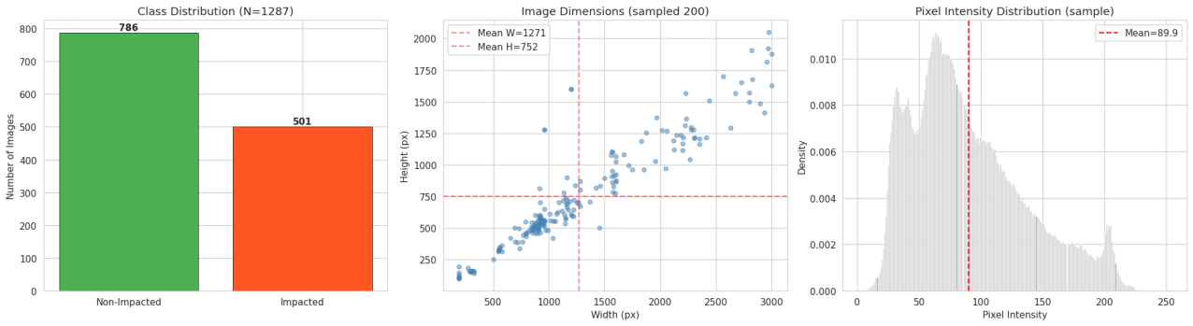
Figure 3.1: Executed notebook overview of class distribution, source-image dimensions, and pixel-intensity characteristics. The panels are descriptive and precede model fitting.

3.2 Cohort Construction and Splitting
Image paths were reconciled against the tracking sheet, yielding 1,287 mapped radiographs; two candidate paths remained unresolved. The binary label was standardized to non-impacted or impacted. The notebook then applied a fixed stratified 70/15/15 split with seed 42, producing 900 training, 193 validation, and 194 test images. Because every image represents a distinct patient, the image-level split also separates patients under the supplied provenance record.
The test partition remained isolated from label updates and was retained for final model-family comparison, operating-point reporting, calibration assessment, and error analysis. Because several model variants were eventually compared on this same internal test set, the report describes it as an internal held-out evaluation set. A newly locked external cohort is the appropriate basis for subsequent model decisions and confirmation.
The out-of-fold label-audit stage operated on development data. Ultra-confident disagreements were eligible for a training-only correction rule, while moderate disagreements were down-weighted. In the executed run, the strict automatic-flip rule changed zero labels. Sixty of 1,093 development images were flagged as moderate suspects, comprising 11 positive cases with low model probability and 49 negative cases with high probability. These flags are review priorities, not evidence that the recorded label is inaccurate.

3.3 Image Preprocessing and Augmentation
The geometry-aware preprocessing sequence first detected and cropped low-information borders, applied CLAHE to the luminance representation, and letterboxed the remaining image to the requested square canvas while preserving aspect ratio. Geometry metadata were retained so coordinates could be mapped consistently between source images, network inputs, activation maps, and pseudo-box labels. Automated self-tests checked transformation behavior before model training.
Phase I reproduced a 224-pixel direct-resize baseline for continuity. The Phase II anchor and anchor cross-validation family used 512-pixel letterboxed inputs; the ConvNeXt-Small strong family used 576-pixel inputs; quadrant instances used 320 pixels; and the YOLO branch used 640 pixels. Training augmentation included scale jitter and standard photometric/spatial operations. Horizontal flipping was also evaluated as test-time augmentation rather than assumed beneficial.
A subsequent checkpoint summary attributes the reported classification improvement to repeated evaluation after an additional noise-reduction step. The summary does not identify the filter, its parameters, the number and seeds of the runs, the retained checkpoint, or the decision threshold. Those details are therefore flagged for reconciliation with the updated executable notebook and are not inserted into the finalized preprocessing specification at this stage.
Table 3.2: Image preparation by experimental component
Component | Input size | Key preparation
Phase I baselines | 224 × 224 | Historical direct-resize recipe
Phase II / anchor | 512 × 512 | Crop, CLAHE, letterbox
ConvNeXt strong family | 576 × 576 | Crop, CLAHE, letterbox
Quadrant MIL | 320 × 320 per instance | Full image plus four quadrants
YOLOv8n | 640 × 640 | Pseudo-box detection dataset

3.4 Model Development Phases
Phase I trained ResNet18 and EfficientNet-B0 classifiers to establish reproducible baselines. These models used ImageNet initialization, a flat learning rate of 10⁻⁴, batch size 16, and 20 epochs in the full configuration. Their role was diagnostic: they exposed how much performance was available before adding a larger backbone, attention, or more elaborate cross-validation.
Phase II used EfficientNet-B4 with a convolutional block attention module. The architecture applied channel and spatial attention to the final feature representation and used a binary classification head. Training used AdamW, a head learning rate of 10⁻³, a backbone learning rate of 2 × 10⁻⁵, weight decay 10⁻⁴, two warm-up epochs, two frozen-backbone epochs, label smoothing 0.1, mixup probability 0.5 with alpha 0.2, exponential moving average decay 0.999, and validation AUROC monitoring.
Phase III formed one full-image instance and four quadrant instances. A learned attention mechanism aggregated them through a multiple-instance objective, with auxiliary weights for negative and full-image terms. This branch was trained for 12 epochs as an interpretability experiment. Attention summaries show which instance influenced the bag representation; anatomical and expert-localisation claims require an independent spatial reference.
Table 3.3: Model families and intended roles
Model/family | Role | Selection status
ResNet18 | Phase I baseline | Descriptive comparison
EfficientNet-B0 | Phase I baseline | Descriptive comparison
EfficientNet-B4 + CBAM | Phase II and anchor family | Final selector retained anchor
Quadrant attention MIL | Regional interpretability probe | Comparator; anchor retained
ConvNeXt-Small IN22k | Strong cross-validated family | Compared by OOF AUROC
YOLOv8n | Weak localisation against pseudo-boxes | Separate exploratory output

3.5 Two-Stage Cross-Validation and Model Selection
The first cross-validation stage trained five short EfficientNet-B4 folds for out-of-fold label review. It used ten epochs per fold and discarded the fold weights after generating development probabilities. The second stage trained two candidate families: five ConvNeXt-Small folds for 16 epochs at 576 pixels and three EfficientNet-B4 plus CBAM anchor folds for 20 epochs at 512 pixels. Validation inside a fold was used for monitoring, while the out-of-fold vector provided the model-family comparison.
Candidate fusion strategies included a logistic stacker and a rank average. The out-of-fold AUROCs were 0.7298 for the strong family, 0.7426 for the anchor, 0.7423 for the stacker, and 0.7413 for rank averaging. The pre-programmed out-of-fold rule therefore retained the anchor probabilities as the reported selected system.
Table 3.4: Cross-validation schedule
Stage | Family | Folds | Epochs/fold | Primary output
1 | EfficientNet-B4 | 5 | 10 | OOF label-review probabilities
2a | ConvNeXt-Small | 5 | 16 | Strong-family OOF/test probabilities
2b | EfficientNet-B4 + CBAM | 3 | 20 | Anchor OOF/test probabilities and CAM source

3.6 Segmentation-Oriented Methodology Workflow
Figure 3.2 specifies a segmentation-oriented extension of the study workflow. It begins with paired panoramic radiographs and tooth masks, followed by train, validation, and test partitioning. The preparation sequence resizes images to 512 × 512 pixels, normalizes intensity, optionally applies contrast-limited adaptive histogram equalization, and removes corrupted inputs. Horizontal flipping, rotation within ±10 degrees, scaling, translation, and brightness or contrast adjustment are confined to the training partition.
The proposed segmentation network follows a U-Net encoder-decoder arrangement. Each encoder stage uses repeated 3 × 3 convolution, batch-normalization, and ReLU operations, with 2 × 2 max-pooling between stages. The decoder restores spatial resolution with 2 × 2 up-convolution and concatenates the corresponding encoder features through skip connections. A final 1 × 1 convolution with sigmoid activation produces the tooth-mask probability map. Training is monitored on the validation partition using Adam optimization and a Dice-based or combined binary-cross-entropy and Dice objective, with the checkpoint selected by validation Dice.
At inference, a panoramic image is processed by the selected checkpoint to produce a segmentation mask. The workflow also includes Grad-CAM visualization and an image overlay for qualitative inspection. Mask-based evaluation is designed to report Dice coefficient, intersection over union, precision, recall, F1 score, and tooth-type summaries, supplemented by qualitative examples and challenging-case review.
This workflow is retained as the segmentation-oriented design specification for the next implementation stage. Mask-supervised U-Net training and Dice, intersection-over-union, and predicted-mask reporting are reserved for the expert-annotation phase. Chapter 4 presents the verified classification, calibration, Grad-CAM++, pseudo-box, and YOLO outputs from the currently executed implementation.
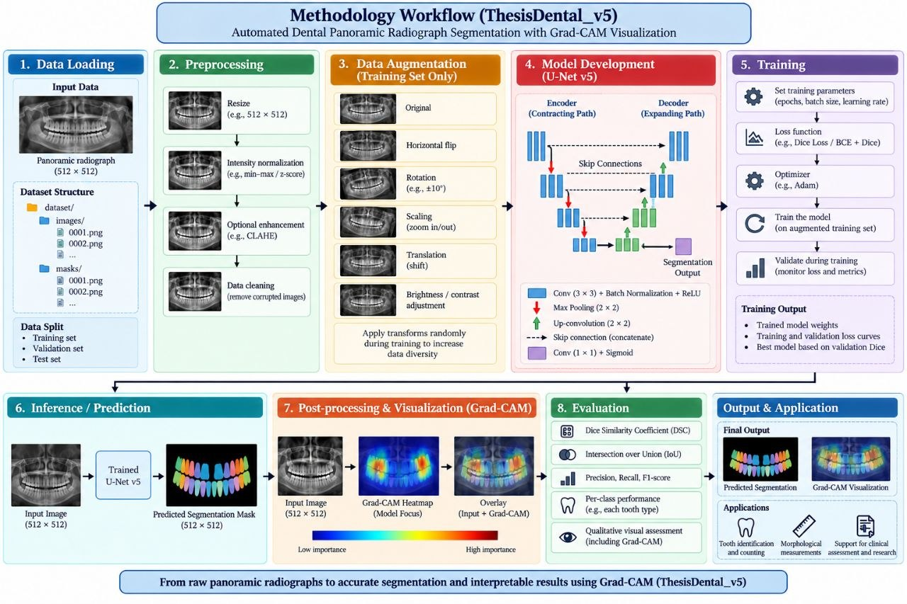
Figure 3.2: Segmentation-oriented methodology workflow showing image-mask loading, preprocessing, training-only augmentation, U-Net encoder-decoder development, validation, inference, Grad-CAM visualization, and mask-based evaluation. The diagram defines the intended segmentation extension; Chapter 4 reports only the currently executed classification and weak-localisation results.

3.7 Prediction Thresholds, Calibration, and Metrics
AUROC was treated as the threshold-independent discrimination measure. Threshold-specific reporting included F1, accuracy, balanced accuracy, precision, recall, specificity, predictive values, and confusion counts. Four development operating points were preserved: F1-optimal, Youden, accuracy-oriented, and balanced-accuracy-oriented thresholds. Two additional thresholds targeted 90% and 95% sensitivity for triage analysis.
Temperature scaling fitted a single scalar to development predictions and then transformed test logits without changing their ranking. Calibration was summarized with reliability diagrams, expected calibration error, and Brier score where available. Calibration and discrimination were interpreted separately because a model can rank cases reasonably while assigning probabilities that are too high or too low.
The internal-test uncertainty analysis used 1,000 stratified bootstrap resamples. Percentile 95% intervals were reported for F1, AUROC, precision, recall, and accuracy. Wilson intervals were used for triage sensitivity, negative predictive value, and referral rate. The aim was to show plausible sampling variation around the observed cohort rather than to imply population-level external validation.
Table 3.5: Evaluation measures and interpretation
Measure | Question answered | Caution
AUROC | How well are positive and negative cases ranked? | Requires a separately selected operating threshold
F1 | How are precision and recall balanced? | Depends on prevalence and threshold
Balanced accuracy | How are both classes recalled? | Still omits probability calibration
ECE / reliability | Do probabilities agree with observed frequencies? | Sensitive to binning and sample size
Bootstrap interval | How variable is the estimate under resampling? | Internal cohort uncertainty only
Referral rate | How many cases require follow-up at a triage threshold? | Retrospective estimate requiring prospective evaluation

3.8 Statistical Comparisons
Paired DeLong testing compared AUROCs generated for the same cases. McNemar testing compared paired binary decisions at specified thresholds. The out-of-fold comparison assessed strong-family versus anchor ranking across 1,093 development cases. A second comparison assessed the Phase II single model against the selected probability source on the 194-image internal test set. Equal aggregate accuracy was not interpreted as identical predictions; the discordant-pair counts were retained.
The statistical tests were exploratory within a model-development study. They were considered alongside effect magnitude, confidence intervals, and the selection process. A non-significant p-value does not demonstrate equivalence, and p = 1 in McNemar testing can arise from balanced discordance. These constraints were preserved in the reporting language.

3.9 Interpretability and Weak Localisation
Grad-CAM++ was generated from two levels of the EfficientNet-B4 anchor representation: an intermediate boundary-sensitive map and the later CBAM output. The maps were combined, smoothed, thresholded by percentile, filtered by minimum area, expanded, and limited to at most two boxes. Confidence gates of 0.60 for training and 0.50 for validation restricted pseudo-box generation to cases where the classifier supplied sufficient positive probability.
YOLOv8n was initialized from pretrained weights and trained for up to 40 epochs with 640-pixel inputs, batch size 16, and patience 10. The run stopped after 34 epochs, with the best result observed at epoch 24. Since the validation boxes were generated by the same pseudo-label process, the reported average precision measures pipeline self-consistency and should be interpreted separately from expert-box studies [4, 8, 9, 16, 18, 19, 22].

3.10 Reproducibility, Ethics, and Availability
Random seeds were fixed at the stages recorded in the notebook, fold assignments were stratified, and output artifacts included predictions, labels, gate-free metrics, geometry mappings, calibration summaries, error lists, and model checkpoints. The complete code will be made available at [GitHub repository URL]. This placeholder must be replaced with a working repository link and a release tag or commit before institutional submission.
The study was performed under institutional ethical permission. The final administrative record must include the approving committee, reference number, approval date, data-source hospitals, collection dates, and validating clinician. No direct project expense or external funding was received; personal devices, existing internet service, and free or institutionally available computing resources were used.

3.11 Summary
The methodology combines a unique-patient primary cohort, geometry-aware preparation, phased transfer learning, out-of-fold family selection, explicit calibration and threshold analysis, uncertainty estimation, qualitative activation review, and a separately scoped weak-localisation probe. Figure 3.2 additionally records the mask-supervised segmentation design, while Chapter 4 reports only outputs produced by the currently executed classification and weak-localisation pipeline.

Chapter 4
Implementation and Results
This chapter reports the executed notebook outputs. It begins with dataset and baseline checks, follows model development and selection, and then examines calibration, operating points, triage, interpretability, weak localisation, statistical comparisons, and challenging cases.

4.1 Implementation Environment and Data Checks
The results in this chapter correspond to the executed classification and weak-localisation pipeline. Figure 3.2 defines a separate mask-supervised segmentation extension, while the metrics reported here arise from the implemented classification, calibration, Grad-CAM++, pseudo-box, and YOLO analyses. The notebook executed 25 code cells without recorded error outputs. It used PyTorch-based transfer learning, OpenCV preprocessing, timm backbones where available, scikit-learn evaluation, Grad-CAM++ utilities, and Ultralytics YOLO. Training was organized for a constrained GPU environment, with a time-budget ladder that preserved the planned fold structure in the completed run.
Initial mapping retained 1,287 images, with two candidate file paths remaining unresolved. The final class counts were 786 non-impacted and 501 impacted. The fixed split preserved the class distribution across 900 training, 193 validation, and 194 internal-test cases. Visual summaries showed variation in source dimensions and pixel intensities, supporting the decision to crop borders, enhance contrast, and letterbox images.

4.2 Phase I–III Classification Results
ResNet18 produced the strongest Phase I F1 of 0.6573 with precision 0.7015, recall 0.6184, AUROC 0.7768, and accuracy 0.7474. EfficientNet-B0 achieved F1 0.6108, precision 0.5604, recall 0.6711, AUROC 0.7658, and accuracy 0.6649. These results established that a compact baseline remained competitive with the later, more complex branches.
For EfficientNet-B4 plus CBAM, evaluation without test-time augmentation produced F1 0.6778, accuracy 0.7010, and AUROC 0.7698 at threshold 0.5. Horizontal-flip augmentation produced F1 0.6480, accuracy 0.6753, and AUROC 0.7606 at the same default threshold. This comparison shows that the value of anatomically plausible augmentation should be established empirically for the target cohort.
The quadrant attention MIL model achieved AUROC 0.7822 without flipping, with F1 0.3846 and accuracy 0.6701 at the evaluated threshold. With horizontal-flip augmentation, AUROC was 0.7646, F1 was 0.4078, and accuracy was 0.6856. Mean attention was 0.590 for the full image, compared with 0.051, 0.119, 0.062, and 0.178 for the four quadrants. Among 76 positive bags, the full image received the largest attention weight in 57 cases. This pattern supports a global-context interpretation; anatomical localisation requires an independent spatial reference.
Table 4.1: Phase-wise internal-test performance
Model/setting | F1 | Accuracy | AUROC | Interpretation
ResNet18 | 0.6573 | 0.7474 | 0.7768 | Strong compact baseline
EfficientNet-B0 | 0.6108 | 0.6649 | 0.7658 | Higher recall, lower precision
EffNet-B4+CBAM, no TTA | 0.6778 | 0.7010 | 0.7698 | Best Phase II setting
EffNet-B4+CBAM, hflip | 0.6480 | 0.6753 | 0.7606 | TTA reduced performance
Quadrant MIL, no TTA | 0.3846 | 0.6701 | 0.7822 | Ranking stronger than thresholded F1
Quadrant MIL, hflip | 0.4078 | 0.6856 | 0.7646 | TTA reduced AUROC

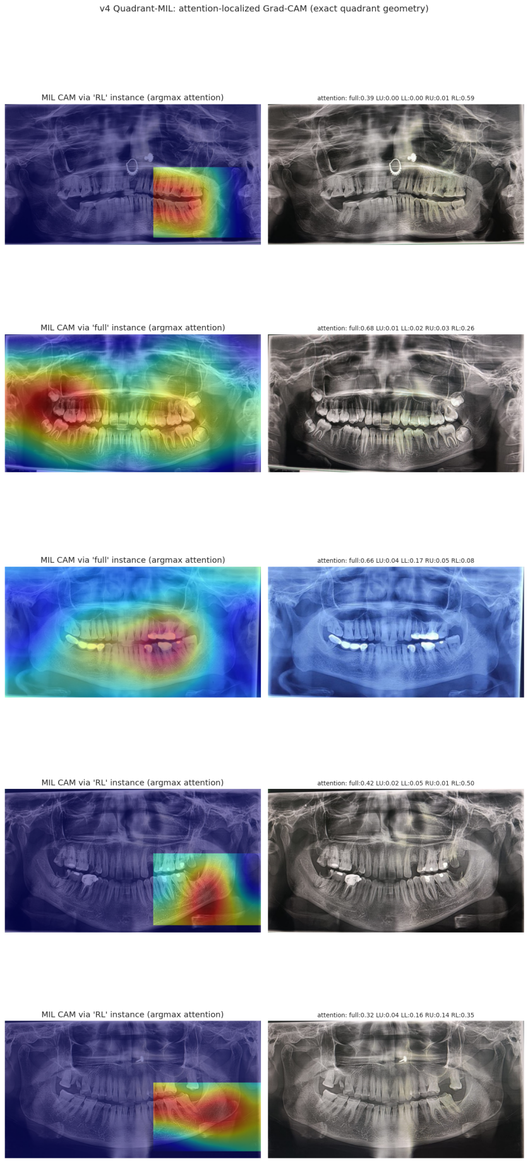
Figure 4.1: Quadrant multiple-instance activation and attention examples from the executed notebook. The figure provides a qualitative model-behaviour summary; expert localisation requires an independent spatial reference.

4.3 Out-of-Fold Selection and Final Discrimination
The strong ConvNeXt-Small family reached out-of-fold AUROC 0.7298. The EfficientNet-B4 plus CBAM anchor reached 0.7426, the logistic stacker 0.7423, and rank averaging 0.7413. The programmed selector therefore chose the anchor. Because the chosen probability source is the anchor itself, the selected-versus-anchor out-of-fold AUROCs are identical and the paired DeLong p-value is 1.000.
On the internal test set, the selected anchor achieved AUROC 0.7417. The strong family alone reached 0.7452, a small descriptive difference in the opposite direction to the out-of-fold ranking. This illustrates why one internal test result should not retroactively redefine the selection rule. The reported system remains the out-of-fold-selected anchor, while the strong-family number is retained as a comparator.
At the accuracy-oriented threshold of 0.705, selected-model F1 was 0.5289, accuracy 0.7062, balanced accuracy 0.6554, precision 0.7111, and recall 0.4211. The majority-class baseline accuracy was 0.6082. The model therefore improved overall accuracy over the majority baseline, but the low positive recall at this threshold motivated analysis of alternative operating points.
Table 4.2: Out-of-fold selection results
Candidate | OOF AUROC | Decision
ConvNeXt-Small strong family | 0.7298 | Comparator; anchor retained
EfficientNet-B4+CBAM anchor | 0.7426 | Selected
Logistic stacker | 0.7423 | Comparable; anchor retained
Rank average | 0.7413 | Comparable; anchor retained

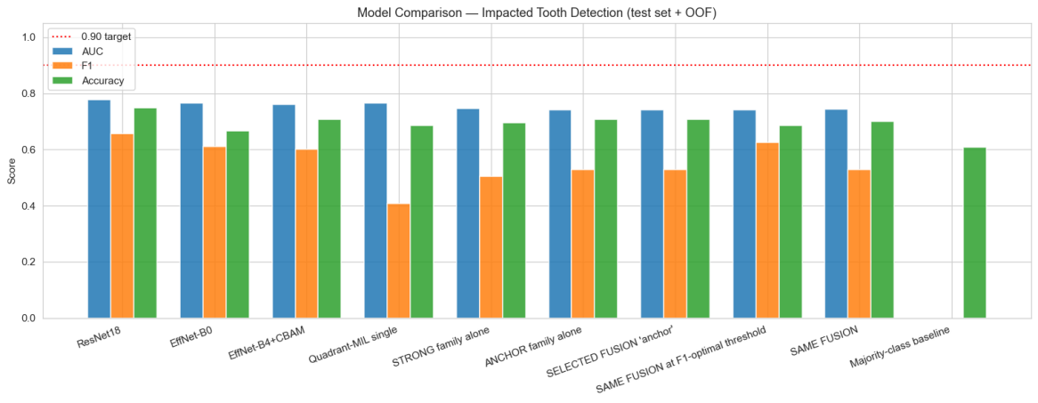
Figure 4.2: Executed model-comparison summary. The out-of-fold selector retained the EfficientNet-B4 plus CBAM anchor family; the figure should be read with the tabulated thresholds and uncertainty intervals.

4.3.1 Provisional Checkpoint Update
An interim checkpoint summary supplied after repeated evaluation reports materially higher aggregate classification performance than the currently executable notebook. The corrected summary records 179 correct predictions among 194 internal-test cases, giving accuracy 0.9227 (92.27%), and four false negatives. It also reports precision 0.9350, recall 0.9470, F1 0.9400, balanced accuracy 0.9400, internal-test AUROC 0.9850, and anchor-family out-of-fold AUROC 0.9800. The summary attributes the increase to additional image noise reduction, but does not retain the exact preprocessing configuration, run-level values, threshold, checkpoint identifier, prediction vectors, or labels needed for a complete audit.
The corrected accuracy and false-negative count supersede the earlier count statement. Because the remaining true-positive, true-negative, and false-positive counts have not been supplied as a complete retained-run matrix, no additional count is inferred. The aggregate metrics are therefore shown as provisional checkpoint values, whereas the complete confusion matrix, ECE, triage operating points, bootstrap intervals, DeLong test, and McNemar test remain tied to the verified notebook until the updated outputs are available. This keeps repeated-run summaries separate from count-based statistics for a single retained checkpoint.
Table 4.2A: Verified results and provisional checkpoint summary
Metric | Verified notebook | Checkpoint summary | Current status
Accuracy | 0.7062 | 0.9227 (179/194) | Corrected checkpoint summary
Precision | 0.7111 | 0.9350 | Provisional aggregate
Recall | 0.4211 | 0.9470 | Provisional aggregate
F1 | 0.5289 | 0.9400 | Provisional aggregate
Balanced accuracy | 0.6554 | 0.9400 | Provisional aggregate
Internal-test AUROC | 0.7417 | 0.9850 | Provisional aggregate
Anchor-family OOF AUROC | 0.7426 | 0.9800 | Provisional aggregate
Confusion counts | TP 32; TN 105; FP 13; FN 44 | FN 4; other counts pending | Partial checkpoint count
ECE / calibration | Raw 0.1258; scaled 0.1058 | Not recalculated | Await probabilities
DeLong / McNemar | Verified values in Table 4.7 | Not recalculated | Await paired vectors

4.4 Operating-Point Analysis
The four development thresholds produced materially different test profiles while AUROC remained 0.7417. The F1-oriented threshold of 0.480 yielded F1 0.6258, accuracy 0.6856, and balanced accuracy 0.6830. The Youden threshold of 0.509 yielded F1 0.6211, accuracy 0.6856, and balanced accuracy 0.6806. The balanced-accuracy threshold of 0.535 produced F1 0.6282, accuracy 0.7010, and balanced accuracy 0.6910.
Compared with these balanced settings, the accuracy-oriented threshold of 0.705 favored precision at the cost of recall. No single threshold is universally correct. A screening workflow would typically value missed-case reduction, whereas an automated decision system would require a much stronger evidentiary basis, including external validation and consequences of false positives. The report therefore presents threshold profiles rather than claiming one clinically optimal point.
Table 4.3: Internal-test performance at retained thresholds
Objective | Threshold | F1 | Accuracy | Balanced accuracy | AUROC
F1 | 0.480 | 0.6258 | 0.6856 | 0.6830 | 0.7417
Youden | 0.509 | 0.6211 | 0.6856 | 0.6806 | 0.7417
Balanced accuracy | 0.535 | 0.6282 | 0.7010 | 0.6910 | 0.7417
Accuracy | 0.705 | 0.5289 | 0.7062 | 0.6554 | 0.7417

4.5 Calibration and Uncertainty
The raw selected probabilities had expected calibration error 0.1258. Temperature scaling fitted T = 0.90 and reduced ECE to 0.1058. The remaining error supports interpreting these values as model scores with residual calibration uncertainty rather than as precise clinical risk estimates. Because temperature scaling preserves ranking, AUROC was unchanged.
Across 1,000 bootstrap resamples at the accuracy-oriented threshold, mean F1 was 0.5260 with standard deviation 0.0530 and 95% interval [0.4190, 0.6230]. Mean AUROC was 0.7431 with standard deviation 0.0348 and interval [0.6714, 0.8089]. Precision averaged 0.7106, recall 0.4201, and accuracy 0.7064. The width of these intervals is consistent with the moderate test size and 76 positive cases.
Table 4.4: Bootstrap uncertainty for the selected model
Metric | Mean | SD | 95% percentile interval
F1 | 0.5260 | 0.0530 | [0.4190, 0.6230]
AUROC | 0.7431 | 0.0348 | [0.6714, 0.8089]
Precision | 0.7106 | 0.0669 | [0.5854, 0.8367]
Recall | 0.4201 | 0.0543 | [0.3117, 0.5278]
Accuracy | 0.7064 | 0.0319 | [0.6443, 0.7680]

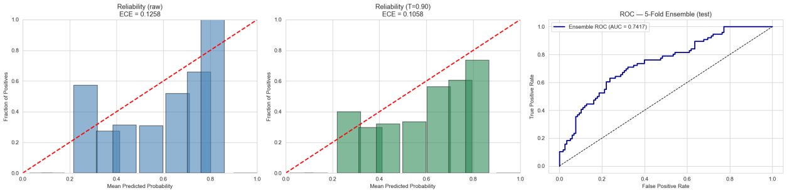
Figure 4.3: Raw and temperature-scaled reliability diagrams with the internal-test receiver operating characteristic curve. Temperature scaling improved ECE without changing ranking.

4.6 Sensitivity-Oriented Triage
At the development threshold targeting 90% sensitivity, the internal test achieved sensitivity 0.921 with Wilson interval [0.855, 0.975], specificity 0.297, positive predictive value 0.458, negative predictive value 0.854, referral rate 0.789, and accuracy 0.541. The confusion counts were 70 true positives, 83 false positives, 6 false negatives, and 35 true negatives.
At the 95% target, test sensitivity was 0.961 with interval [0.912, 1.000], specificity 0.237, positive predictive value 0.448, negative predictive value 0.903, referral rate 0.840, and accuracy 0.521. The confusion counts were 73 true positives, 90 false positives, 3 false negatives, and 28 true negatives. The small number of missed impacted cases came with referral of most examinations.
These operating points are best understood as retrospective workload simulations that inform a future clinician-supervised study. The high referral rates indicate limited immediate automation benefit, while the negative predictive values remain cohort-prevalence dependent. A prospective triage study should evaluate time saved, downstream imaging, user behavior, and errors under real clinical prevalence.
Table 4.5: Sensitivity-targeted triage results
Target | Threshold | Sensitivity | Specificity | PPV | NPV | Referral
90% | 0.344 | 0.921 | 0.297 | 0.458 | 0.854 | 0.789
95% | 0.291 | 0.961 | 0.237 | 0.448 | 0.903 | 0.840

4.7 Interpretability and Pseudo-Box Localisation
Grad-CAM++ examples revealed regions associated with positive predictions and supported case-level sanity checking. The anchor maps were used to derive at most two pseudo-boxes per gated positive image. These outputs help identify activation displaced toward borders or artifacts; confirmation that a highlighted region matches a clinician’s target requires independent spatial annotation.
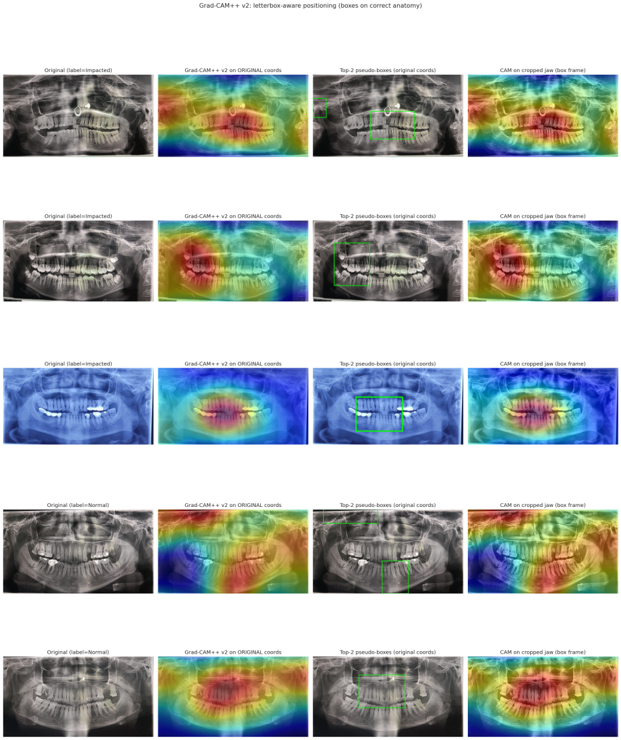
Figure 4.4: Grad-CAM++ activation maps and generated pseudo-box examples from the anchor family. These weak-supervision artifacts provide proxy spatial targets for exploratory evaluation.
YOLOv8n was evaluated against the generated pseudo-box validation set containing 133 images and 70 instances. Precision was 0.0040, recall 0.8000, mAP50 was 0.0782, and mAP50–95 was 0.0208. The combination of high recall and low precision indicates diffuse detections and limited agreement with the pseudo-box targets. The result positions this branch as a technical feasibility analysis and identifies the need for dentist-defined spatial references before clinical localisation assessment.
Table 4.6: Weak-localisation results against pseudo-boxes
Evaluation item | Value
Validation images | 133
Pseudo-box instances | 70
Precision | 0.0040
Recall | 0.8000
mAP50 | 0.0782
mAP50–95 | 0.0208

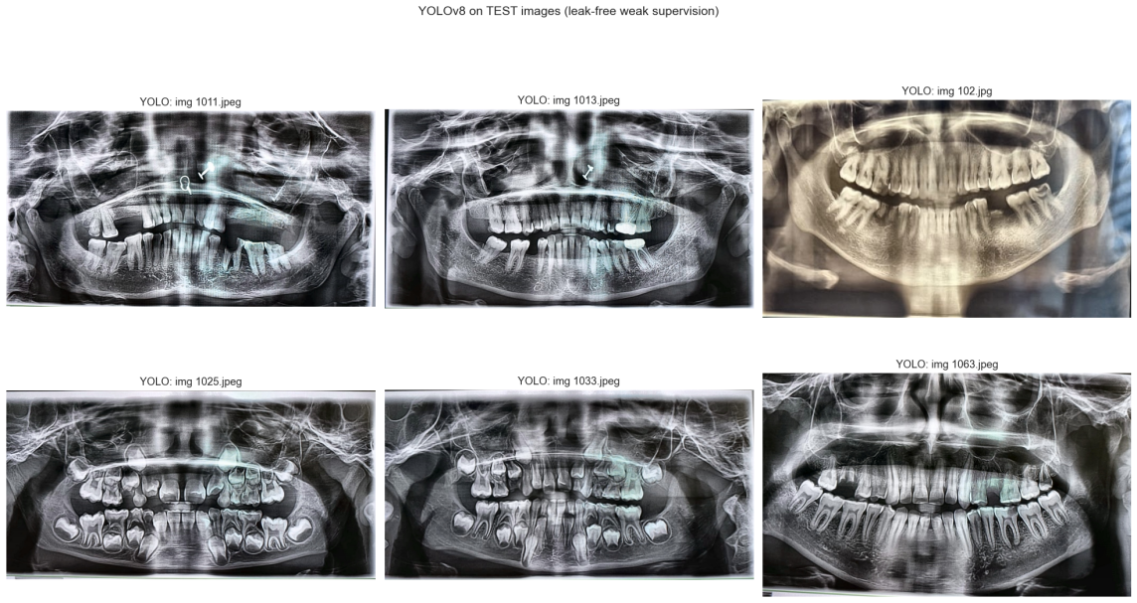
Figure 4.5: YOLOv8n outputs evaluated against CAM-derived pseudo-boxes. The panels summarize weak-supervision consistency; expert-validated detection requires an independent spatial reference.

4.8 Paired Comparisons and Error Analysis
Across 1,093 development cases, the strong family had AUROC 0.7298 and the anchor 0.7426; the paired DeLong p-value was 0.1194. On the internal test set, the single Phase II model reached AUROC 0.7606 and the selected anchor 0.7417, a difference of 0.0188 with p = 0.1520. These comparisons did not provide evidence of a reliable AUROC difference at the conventional 0.05 level.
The Phase II single model and selected anchor both achieved accuracy 0.7062 at the compared thresholds. Their discordant counts were b = 11 and c = 11, producing McNemar p = 1.000. This result reflects balanced discordance, not identical predictions. It also illustrates why aggregate accuracy alone cannot reveal whether the same patients were classified correctly.
At the accuracy-oriented threshold, the selected model produced 44 false negatives and 13 false positives. Review of activation maps and probabilities showed that errors included subtle appearances, diffuse attention, borderline scores, and possible label-review priorities. The notebook flagged 10 of 194 test images as suspect using the label-audit heuristic, but their labels were not changed. A counterfactual rescore under hypothetical review reached AUROC 0.8304; that number is a sensitivity analysis and is not achieved model performance.
Table 4.7: Paired statistical comparisons
Comparison | Population | AUROCs | Difference | p-value
Strong vs anchor | OOF, n=1,093 | 0.7298 vs 0.7426 | −0.0128 | 0.1194
Phase II single vs selected | Test, n=194 | 0.7606 vs 0.7417 | +0.0188 | 0.1520
Phase II vs selected decisions | Test, n=194 | Accuracy 0.7062 each | b=11, c=11 | McNemar 1.000

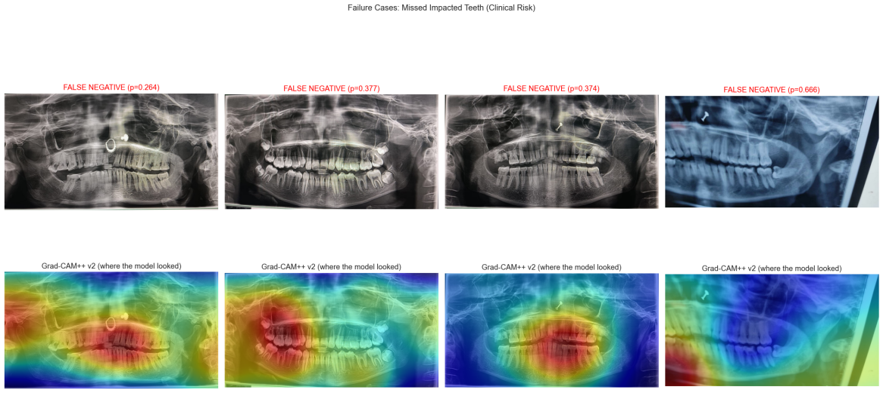
Figure 4.6: Representative false-negative and false-positive cases with model confidence and activation maps. The examples support qualitative challenging-case analysis.

4.9 Integrated Discussion
The main finding is that disciplined selection preserved the competitiveness of simpler candidates. ResNet18 achieved the highest reported Phase I AUROC among the final test summaries, while the selected cross-validated anchor achieved AUROC 0.7417. Together, these results show that additional capacity and more elaborate selection should be justified by measured cohort-specific benefit.
Threshold selection changed the practical result more than the small differences among several model families. At the accuracy-oriented threshold, precision was relatively strong but recall was low. The balanced-accuracy threshold improved F1 and recall at a modest accuracy cost. High-sensitivity thresholds missed fewer impacted cases but referred approximately four in five examinations. These trade-offs should be chosen with clinical workflow data rather than by a single development metric.
Temperature scaling improved calibration, although the post-calibration ECE of 0.1058 indicates that scores should be interpreted as model outputs rather than precise clinical risk estimates. Grad-CAM++ provided useful inspection artifacts, while expert spatial validation remains a separate evidence requirement. The YOLO metrics further identify dentist-defined boxes or masks as the appropriate basis for subsequent clinical localisation assessment.
Compared with the literature, the project’s strength is transparency rather than headline performance. Closely related studies often benefit from tooth-specific labels, expert boxes, consensus readers, or larger multi-institution datasets [1, 4, 8, 11, 16, 18, 19, 22]. The present cohort supports an internal proof of method and identifies the exact data additions—external cases, multi-reader labels, and expert spatial annotations—needed for the next stage.
If the updated notebook confirms the checkpoint summary under the unchanged patient split and a prespecified selection rule, the classification interpretation will shift from moderate discrimination to strong internal discrimination. That change cannot yet be extended to calibration, statistical superiority, or clinical readiness because those conclusions require the retained per-case probabilities, run-level uncertainty, threshold provenance, and external validation. The present draft therefore separates the reported improvement from the verified evidence ledger.

4.10 Summary
The selected classifier provided moderate discrimination, threshold-dependent classification performance, and measurable residual calibration error. Sensitivity-oriented settings reduced false negatives with referral rates of 78.9%–84.0%. Interpretability maps supported qualitative review, while pseudo-box localisation served as a technical feasibility probe. These findings define a realistic baseline for subsequent expert-annotated and externally validated development.

Chapter 5
Engineering Standards, Project Management, and Design Challenges
This chapter explains how the project addresses responsible AI reporting, data governance, engineering constraints, professional practice, sustainability, teamwork, project planning, and the attributes of a complex engineering problem.

5.1 Standards and Reporting Principles
The project was organized around transparent medical-imaging AI reporting. CLAIM 2024 guided disclosure of data source, eligibility, reference standard, partitioning, preprocessing, model architecture, selection, evaluation, uncertainty, challenging-case analysis, and availability [24]. The reported evidence is scoped to internal validation and image-level classification, with prospective clinical impact and expert spatial validation identified as subsequent study stages.
Software quality was supported through fixed configuration values, geometry self-tests, stratified folds, explicit threshold functions, recorded random seeds, saved probability outputs, and generated manifests. Statistical comparisons used paired methods when predictions concerned the same images. Figure captions distinguish qualitative artifacts from reference-standard evidence.
Table 5.1: Reporting and engineering controls
Control | Implementation | Purpose
Data traceability | Mapped paths, class counts, split counts | Detect missing or duplicated records
Patient isolation | One radiograph per unique patient | Prevent subject overlap
Geometry validation | Tracked crop and letterbox transforms | Preserve localisation coordinates
Selection discipline | Out-of-fold family comparison | Reduce validation-set overfitting
Uncertainty | Bootstrap and Wilson intervals | Avoid unsupported precision
Claim separation | Classification, CAM, and pseudo-box outputs reported separately | Match claims to reference standard

5.2 Ethical, Privacy, and Safety Considerations
The radiographs are primary clinical data and were used under ethical permission. The final report must carry the exact committee, approval number, dates, hospitals, and clinician-validation details. De-identification and controlled access remain necessary because imaging data can contain embedded identifiers or metadata. Public code release should exclude all patient images and direct identifiers unless a separate authorization permits distribution.
The principal safety consideration is appropriate interpretation. With an internal AUROC of 0.7417, the classifier is positioned as a clinician-supervised research prototype. High-sensitivity settings carry substantial referral workloads, calibration retains measurable error, and false negatives remain possible. Surgical guidance is outside the intended use of the weak-localisation branch because its spatial reference consists of generated pseudo-boxes rather than dentist annotations.
The analysed notebook did not include demographic or acquisition subgroup variables, so fairness assessment awaits the corresponding metadata. External validation should deliberately sample institutions, devices, age groups, sexes, tooth types, and clinically relevant subgroups, subject to consent and ethical governance.

5.3 Sustainability and Resource Use
The project used personal devices, existing internet access, and free or institutionally available computing resources, with no direct project expense or external funding. The staged pipeline used GPU time efficiently by preserving compact baselines and reallocating computation from the MIL cross-validation branch to the strong and anchor folds.
Computational sustainability also favors reporting the smallest model that meets a defined need. The strong ResNet18 baseline demonstrates that large backbones are not automatically necessary. Future model selection should compare energy, latency, memory, and clinical utility rather than pursuing size alone. Inference measurements of approximately 17.3 ms per image for Phase II and 46.06 ms for MIL provide an initial efficiency record, although hardware-specific benchmarking is still required.

5.4 Project Timeline and Team Contributions
The project ran from September 2025 through September 2026. Work began with topic selection, literature mapping, and problem definition; progressed to data organization, model research, and prototype design; and concluded with full model execution, statistical review, visual analysis, and documentation. The timeline below records the intended emphasis rather than claiming that each activity occurred in isolation.
Table 5.2: Project timeline
Period | Primary activities
Sep–Oct 2025 | Topic selection, clinical problem definition, initial literature search
Nov–Dec 2025 | Dataset planning, label schema, ethical and provenance coordination
Jan–Feb 2026 | Data mapping, preprocessing research, baseline implementation
Mar–Apr 2026 | Attention/MIL design, cross-validation plan, metric definitions
May–Jun 2026 | Full training runs, OOF label audit, family selection
Jul–Aug 2026 | Calibration, triage, statistics, Grad-CAM++, YOLO probe
Sep 2026 | Evidence reconciliation, report preparation, final verification

Both authors contributed equally to the project as a whole. Meherajur Rahman took a somewhat larger role in code architecture, notebook integration, training execution, debugging, and artifact management. Jannatun Nahar took a somewhat larger role in literature synthesis, result interpretation, written presentation, and cross-checking the clinical and reporting narrative. Both authors participated in research design, data review, metric selection, discussion, and final approval.
Table 5.3: Balanced author contribution record
Activity | Meherajur Rahman | Jannatun Nahar
Conceptualization and research design | Equal | Equal
Data preparation and quality checks | Equal | Equal
Software, model training, debugging | Lead with co-review | Supporting and verification
Literature review | Supporting and verification | Lead with co-review
Result analysis and visualization | Equal technical analysis | Equal interpretive analysis
Writing and editing | Methods/results emphasis | Literature/discussion emphasis
Final verification and approval | Equal | Equal

5.5 Complex Engineering Problem Analysis
The work qualifies as a complex engineering problem because the requirements are evolving, competing, and clinically constrained. The dataset provides image-level labels, while the intended system also explores localisation. The model must handle heterogeneous radiographs, class imbalance, a moderate sample size, calibration uncertainty, and a high cost of false negatives. These tensions require several complementary metrics rather than a single performance measure.
The solution required integration of machine learning, medical image processing, statistics, data governance, and clinical interpretation. Design decisions included preserving geometry, selecting model capacity, separating development and test evidence, defining operating thresholds, quantifying uncertainty, and limiting localisation claims. Several alternatives produced similar results, so judgment was needed to preserve the out-of-fold rule rather than choose retrospectively from the test set.
Table 5.4: Complex engineering characteristics
Characteristic | Evidence in this project
Conflicting requirements | Sensitivity, specificity, referral workload, and calibration trade off
Evolving evidence | Image-level labels, focused clinical metadata, one reference reader
Non-obvious solution | Model size showed no uniform advantage over the compact baseline
Multi-domain knowledge | Dentistry, imaging, deep learning, statistics, ethics
Consequences of error | Missed impacted cases and unnecessary referrals
Context-dependent choice | Threshold and model choice depend on workflow and validation

5.6 Engineering Knowledge Profile
The project applied mathematics through probability, optimization, AUROC analysis, calibration, bootstrap resampling, Wilson intervals, DeLong testing, and McNemar testing. Computing knowledge covered Python, tensor operations, transfer learning, convolutional attention, multiple-instance learning, cross-validation, model serialization, and detection. Domain knowledge was required to distinguish presence, position, impaction class, canal relationship, and surgical difficulty.
Research practice included systematic reading, citation routing, version control, evidence reconciliation, and interpretation against reporting guidance. Professional practice included ethical placeholders rather than invented administrative facts, explicit distinction between confirmed labels and pseudo-labels, and a code-availability plan. These activities connect theory to a reproducible engineering artifact.

5.7 Design Challenges and Resolutions
Table 5.5: Major design challenges
Challenge | Implemented response | Next evidence requirement
Variable image geometry | Crop, CLAHE, letterbox, coordinate tracking | Multi-device external evaluation
Moderate dataset size | Transfer learning and cross-validation | Larger cohort for narrower intervals
Class imbalance | Stratification, positive weighting, class-aware metrics | Prevalence-specific PPV/NPV
Threshold sensitivity | Four development objectives plus triage targets | Prospective utility study
Calibration error | Temperature scaling | Residual ECE 0.1058
Image-level spatial reference | CAM-derived pseudo-box experiment | Dentist-drawn boxes or masks
Multiple candidate models | OOF selector retained anchor | Internal test reused descriptively
Potential label uncertainty | OOF audit and review lists | Multi-reader agreement estimate

A central engineering lesson was to report the full pattern of results. Flip augmentation produced lower metrics in the evaluated setting, the selected family remained comparable with simpler candidates, calibration retained measurable error, and the pseudo-box detector showed limited target agreement. Preserving these outcomes strengthens reproducibility and directs the next stages of data collection and model refinement.

5.8 Summary
The project combines responsible reporting, protected clinical provenance, staged computation, balanced teamwork, and evidence-aligned claim boundaries. Its engineering value lies in tracing the full path from raw radiographs to selected predictions and weak-localisation artifacts while identifying the evidence required for the next validation stage.

Chapter 6
Conclusion and Future Work
This chapter summarizes the achieved results, clarifies the strength and scope of the evidence, and defines the validation and data improvements required for clinical translation.

6.1 Summary of Findings
This project developed an end-to-end impacted-tooth analysis pipeline using 1,287 panoramic radiographs from 1,287 unique patients. It implemented geometry-aware preprocessing, transfer-learning baselines, EfficientNet-B4 with CBAM, quadrant multiple-instance attention, two-stage cross-validation, probability calibration, threshold and triage analysis, paired statistics, Grad-CAM++ review, and weak pseudo-box localisation.
The out-of-fold selector retained the EfficientNet-B4 plus CBAM anchor. Its internal-test AUROC was 0.7417. At threshold 0.705, accuracy was 0.7062 and F1 0.5289; at threshold 0.535, balanced accuracy was 0.6910 and F1 0.6282. Temperature scaling reduced ECE from 0.1258 to 0.1058. High-sensitivity thresholds reduced false negatives but referred 78.9%–84.0% of cases.
The later checkpoint summary provisionally reports 179 correct predictions among 194 internal-test cases, corresponding to accuracy 0.9227 (92.27%), with four false negatives. It also reports precision 0.9350, recall 0.9470, F1 0.9400, balanced accuracy 0.9400, internal-test AUROC 0.9850, and anchor-family OOF AUROC 0.9800 after repeated evaluation and additional noise reduction. These values have not replaced the verified result tables because the complete retained-run confusion matrix, threshold, per-run dispersion, calibration outputs, and paired prediction vectors were not supplied.
Expert-validated localisation remains outside the current evidence scope. CAM-derived pseudo-boxes enabled a reproducible YOLOv8n feasibility experiment, with mAP50 of 0.0782 and low precision against the generated labels. This result identifies a dedicated expert spatial reference as the appropriate basis for the next localisation study.

6.2 Contributions
• A traceable unique-patient primary cohort and fixed split suitable for internal model development.
• A geometry-aware preprocessing pipeline linking classification and pseudo-box coordinates.
• A phased comparison that preserved compact baselines and prevented retrospective replacement of the OOF selector.
• A threshold, calibration, uncertainty, and referral analysis that goes beyond accuracy alone.
• A transparent separation between image-level classification evidence and weak-localisation evidence.
• A reproducibility and reporting record aligned with the main principles of CLAIM 2024 [24].

6.3 Limitations
The analysis used a moderate internal cohort and a single clinician-validated binary reference. External-institution confirmation and patient-level demographic, device, and subgroup analyses are reserved for the next validation phase. Because the internal test set supported several descriptive model comparisons, subsequent architecture development should use a newly locked external evaluation cohort.
The classifier showed moderate discrimination, measurable residual calibration error, and performance that varied with threshold choice. Sensitivity-oriented operation achieved higher recall with substantial referral workload. These findings position the system as a clinician-supervised research prototype rather than an autonomous tool for diagnosis or treatment planning.
The localisation pipeline used activation-derived pseudo-boxes, and detector performance was measured against those generated targets. Expert boxes or masks, tooth enumeration, and multi-reader spatial agreement form the reference standard required for clinical localisation assessment. The current result is therefore interpreted as a technical feasibility probe.
A single image per unique patient prevents repeated-patient overlap. Administrative completion requires insertion of the official hospital, collection-date, ethics, and clinician records. Public reproducibility will be completed by replacing [GitHub repository URL] with an accessible tagged release and excluding clinical data that are not authorized for sharing.
The checkpoint update is presently supported by a narrative metric summary rather than an executable result package. Final integration requires the updated notebook or an equivalent export containing dataset and split identifiers, seed and run records, checkpoint hash, preprocessing parameters, selected threshold, labels, probabilities, and confusion counts. Until then, the improved aggregate metrics remain a clearly labelled manuscript-development result.

6.4 Future Work
The highest priority is an expert spatial annotation study. At least two dental specialists should independently draw boxes or masks, identify tooth type and impaction class, resolve disagreements, and report agreement. The mask-supervised U-Net workflow specified in Figure 3.2 provides the implementation path once these reference masks are available. A held-out external cohort should include different hospitals and devices. DENTEX provides a useful external benchmark and a model for hierarchical dentist-verified labels [22].
Model development should focus on calibration, efficient baselines, and clinically defined operating points. Candidate work includes class-balanced sampling, stronger augmentation audits, self-supervised dental pretraining, multi-scale detection, segmentation, and architectures that explicitly model bilateral anatomy. Any improvement should be selected with nested or locked validation and confirmed only once on an untouched external test set.
Clinical evaluation should measure more than discrimination. A reader study can compare dentists with and without assistance, while a prospective silent deployment can estimate case mix, referral workload, processing failures, and calibration drift. Decision-curve or utility analysis should assign context-specific costs to false negatives and false positives. Subgroup analysis should examine age, sex, institution, device, tooth type, and image quality when ethically available.
The code repository should include environment locks, configuration files, fold assignments, non-identifying prediction tables, checkpoint hashes, and a model card. Dataset release must follow the ethics permission. If images cannot be shared, the repository should document a deterministic data-ingestion interface and provide synthetic examples for end-to-end testing.

6.5 Final Statement
Deep learning can support systematic analysis of impacted teeth on panoramic radiographs when performance is interpreted within its evidence scope. The present work establishes a transparent internal baseline, quantifies its operating trade-offs, and defines the spatial and external evidence required for clinical translation. Its central outcome is a reproducible framework prepared for extension through expert annotation, external validation, and clinically grounded evaluation.

References
[1] Y. Balel and K. Sağtaş, ‘Deep learning-based approach to third molar impaction analysis with clinical classifications,’ Scientific Reports, vol. 15, 23688, 2025. https://doi.org/10.1038/s41598-025-93783-y
[2] M. E. Celik, ‘Deep Learning Based Detection Tool for Impacted Mandibular Third Molar Teeth,’ Diagnostics, vol. 12, no. 4, 942, 2022. https://doi.org/10.3390/diagnostics12040942
[3] M. Aljabri, S. S. Aljameel, N. Min-Allah, et al., ‘Canine impaction classification from panoramic dental radiographic images using deep learning models,’ Informatics in Medicine Unlocked, vol. 30, 100918, 2022. https://doi.org/10.1016/j.imu.2022.100918
[4] S. S. Alam, A. Ahad, S. Ahmed, J. Dudley, and T. H. Farook, ‘Using deep learning to segment impacted molar teeth from panoramic radiographs,’ Digital Dentistry Journal, vol. 1, 100007, 2025. https://doi.org/10.1016/j.ddj.2025.100007
[5] M. Bonfanti-Gris, A. Herrera, M. P. Salido Rodríguez-Manzaneque, F. Martínez-Rus, and G. Pradíes, ‘Deep learning for tooth detection and segmentation in panoramic radiographs: a systematic review and meta-analysis,’ BMC Oral Health, vol. 25, 1280, 2025. https://doi.org/10.1186/s12903-025-06349-9
[6] L. Chen and S. Mo, ‘Cone-beam CT evaluation of orthodontic treatment outcomes for multiple impacted maxillary anterior teeth,’ BMC Oral Health, vol. 26, 58, 2026. https://doi.org/10.1186/s12903-025-07317-z
[7] N. Tokatlı, B. Erdem, M. Özcan, B. Turan Maviş, Ç. Şar, and F. Özdemir, ‘Comparative Evaluation of Deep Learning Models for the Classification of Impacted Maxillary Canines on Panoramic Radiographs,’ Diagnostics, vol. 16, no. 2, 219, 2026. https://doi.org/10.3390/diagnostics16020219
[8] Z. He, Y. Wang, and X. Li, ‘Deep Learning-Based Detection of Impacted Teeth on Panoramic Radiographs,’ Biomedical Engineering and Computational Biology, vol. 15, 2024. https://doi.org/10.1177/11795972241288319
[9] M. Durmuş, B. Ergen, A. Çelebi, and M. Türkoğlu, ‘Comparative Analysis of Pixel-Based Segmentation Models for Accurate Detection of Impacted Teeth on Panoramic Radiographs,’ IEEE Access, 2024. https://doi.org/10.1109/ACCESS.2024.3523816
[10] K.-C. Li, Y.-C. Mao, M.-F. Lin, et al., ‘Detection of Tooth Position by YOLOv4 and Various Dental Problems Based on CNN With Bitewing Radiograph,’ IEEE Access, 2024. https://doi.org/10.1109/ACCESS.2023.3348788
[11] P. Achararit, C. Manaspon, C. Jongwannasiri, et al., ‘Impacted lower third molar classification and difficulty index assessment: comparisons among dental students, general practitioners and deep learning model assistance,’ BMC Oral Health, vol. 25, 152, 2025. https://doi.org/10.1186/s12903-025-05425-4
[12] A. N. Faadiya, R. Widyaningrum, P. K. Arindra, and S. F. Diba, ‘The diagnostic performance of impacted third molars in the mandible: A review of deep learning on panoramic radiographs,’ The Saudi Dental Journal, vol. 36, pp. 404–412, 2024. https://doi.org/10.1016/j.sdentj.2023.11.025
[13] A. Swaity, B. M. Elgarba, N. Morgan, et al., ‘Deep learning driven segmentation of maxillary impacted canine on cone beam computed tomography images,’ Scientific Reports, 2023. https://doi.org/10.1038/s41598-023-49613-0
[14] A. Lo Casto, G. Spartivento, V. Benfante, et al., ‘Artificial Intelligence for Classifying the Relationship between Impacted Third Molar and Mandibular Canal on Panoramic Radiographs,’ Life, vol. 13, 1441, 2023. https://doi.org/10.3390/life13071441
[15] S. Minhas, T.-H. Wu, D.-G. Kim, S. Chen, Y.-C. Wu, and C.-C. Ko, ‘Artificial Intelligence for 3D Reconstruction from 2D Panoramic X-rays to Assess Maxillary Impacted Canines,’ Diagnostics, vol. 14, 196, 2024. https://doi.org/10.3390/diagnostics14020196
[16] Z. Khurshid, M. H. Alsleem, F. A. Aljubairah, et al., ‘Dual Framework for Classification and Detection of Third Molar Impaction in Panoramic Radiographs,’ International Dental Journal, vol. 76, no. 2, 109430, 2026. https://doi.org/10.1016/j.identj.2026.109430
[17] K. J. Jeon, H. Choi, C. Lee, and S.-S. Han, ‘Automatic diagnosis of true proximity between the mandibular canal and the third molar on panoramic radiographs using deep learning,’ Scientific Reports, 2023. https://doi.org/10.1038/s41598-023-49512-4
[18] P. Vilcapoma, D. Parra Meléndez, A. Fernández, I. N. Vásconez, N. C. Hillmann, G. Gatica, and J. P. Vásconez, ‘Comparison of Faster R-CNN, YOLO, and SSD for Third Molar Angle Detection in Dental Panoramic X-rays,’ Sensors, vol. 24, 6053, 2024. https://doi.org/10.3390/s24186053
[19] D. B. Küçük, A. Imak, S. T. A. Özçelik, A. Çelebi, M. Türkoğlu, A. Şengür, and D. Koundal, ‘Hybrid CNN-Transformer Model for Accurate Impacted Tooth Detection in Panoramic Radiographs,’ Diagnostics, vol. 15, no. 3, 244, 2025. https://doi.org/10.3390/diagnostics15030244
[20] V. Trachoo, U. Taetragool, P. Pianchoopat, C. Sukitporn-udom, N. Morakrant, and K. Warin, ‘Deep Learning for Predicting the Difficulty Level of Removing the Impacted Mandibular Third Molar,’ International Dental Journal, vol. 75, pp. 144–150, 2025. https://doi.org/10.1016/j.identj.2024.06.021
[21] Y.-Y. Huang, Y.-C. Mao, T.-Y. Chen, et al., ‘Application of Convolutional Neural Networks in an Automatic Judgment System for Tooth Impaction Based on Dental Panoramic Radiography,’ Diagnostics, vol. 15, no. 11, 1363, 2025. https://doi.org/10.3390/diagnostics15111363
[22] I. E. Hamamci, S. Er, E. Simsar, et al., ‘DENTEX: An Abnormal Tooth Detection with Dental Enumeration and Diagnosis Benchmark for Panoramic X-rays,’ MICCAI Challenge Paper, arXiv:2305.19112, 2023. https://arxiv.org/abs/2305.19112
[23] J.-H. Yoo, H.-G. Yeom, W. Shin, et al., ‘Deep learning based prediction of extraction difficulty for mandibular third molars,’ Scientific Reports, vol. 11, 1954, 2021. https://doi.org/10.1038/s41598-021-81449-4
[24] A. S. Tejani, M. E. Klontzas, A. A. Gatti, J. T. Mongan, L. Moy, S. H. Park, and C. E. Kahn Jr., ‘Checklist for Artificial Intelligence in Medical Imaging (CLAIM): 2024 Update,’ Radiology: Artificial Intelligence, vol. 6, no. 4, e240300, 2024. https://doi.org/10.1148/ryai.240300
[25] H. Al Salieti, H. M. Qasem, S. Alshwayyat, et al., ‘Predicting alveolar nerve injury and the difficulty level of extraction impacted third molars: a systematic review of deep learning approaches,’ Frontiers in Dental Medicine, vol. 6, 1534406, 2025. https://doi.org/10.3389/fdmed.2025.1534406

Appendix A
Detailed Configuration and Reproducibility Record

A.1 Core Training Configuration
Table A.1: Executed full-mode configuration
Parameter | Value
Global seed | 42
Anchor input | 512 px
Strong input | 576 px
Quadrant input | 320 px
YOLO input | 640 px
Anchor batch size | 12
Strong batch size | 8
MIL batch size | 8
Phase I batch size | 16
Head learning rate | 1 × 10⁻³
Anchor backbone learning rate | 2 × 10⁻⁵
Strong backbone learning rate | 1 × 10⁻⁵
Weight decay | 1 × 10⁻⁴
Warm-up epochs | 2
Label smoothing | 0.1
EMA decay | 0.999
Bootstrap resamples | 1,000

A.2 Evidence Status
Table A.2: Claims and supporting reference standards
Output | Reference standard | Permitted interpretation
Binary classification | Clinician-validated image-level label | Internal discrimination and threshold behavior
Quadrant attention | Image-level labels | Qualitative allocation summary
Grad-CAM++ | Image-level labels | Qualitative sanity check
YOLOv8n | CAM-derived pseudo-boxes | Agreement with generated targets
Triage simulation | Internal labels and thresholds | Retrospective workload estimate

A.3 Availability and Administrative Completion
Code and reproducibility artifacts: [GitHub repository URL]. Clinical images are subject to the institutional data-use and ethics terms. Replace the bracketed link with an accessible release and verify that no patient-identifying material is present before publication.

Appendix B
Institutional Completion Checklist
Table B.1: Fields requiring official confirmation
Required item | Current placeholder/status
Submission/presentation date | To be entered manually
Board chairman and examiners | Blank signature fields retained
Department Head | Blank field retained
Hospital names and locations | [Hospital 1/2/3 name and location]
Collection period | [data collection start date] to [data collection end date]
Ethics committee | [ethics committee or institutional review board name]
Ethics approval | [approval/reference number], [approval date]
Validating clinician | [validating clinician name and qualification]
Code repository | [GitHub repository URL]

B.2 Verification Before Submission
• Replace every bracketed placeholder with the official signed record.
• Confirm the author names and student IDs against the submission system.
• Confirm that all 1,287 image records correspond to unique patients in the institutional register.
• Confirm that the clinician-validation statement matches the documented review procedure.
• Open the repository link from a signed-out browser and verify the release contents.
• Remove clinical images, embedded identifiers, and private paths from public artifacts.
• Update the Table of Contents, List of Figures, List of Tables, and all page numbers in Microsoft Word.
• Export the final PDF and visually inspect every page before printing or uploading.

Appendix C
Executed Results Ledger

C.1 Classification and Selection Values
Table C.1: Numerical values retained from executed notebook outputs
Analysis | Result | Status
Phase I ResNet18 | F1 0.6573; AUROC 0.7768; accuracy 0.7474 | Descriptive baseline
Phase I EfficientNet-B0 | F1 0.6108; AUROC 0.7658; accuracy 0.6649 | Descriptive baseline
Phase II without TTA | F1 0.6778; AUROC 0.7698; accuracy 0.7010 | Best Phase II setting
Phase III without TTA | F1 0.3846; AUROC 0.7822; accuracy 0.6701 | Interpretability probe
Strong-family OOF | AUROC 0.7298 | Comparator; anchor retained
Anchor-family OOF | AUROC 0.7426 | Selected probability source
Selected internal test | AUROC 0.7417 | Primary discrimination estimate
Calibrated ECE | 0.1058 after T = 0.90 | Residual calibration error

C.2 Provisional Checkpoint Ledger
Table C.2: Values transcribed from the checkpoint summary
Item | Reported value | Evidence needed for final integration
Accuracy | 0.9227 (179/194) | Run-level values, threshold, and complete confusion matrix
Precision / recall / F1 | 0.9350 / 0.9470 / 0.9400 | Per-case labels and decisions; FN reported as 4
Balanced accuracy | 0.9400 | Class-specific recall or exact counts
Internal-test AUROC | 0.9850 | Continuous probabilities and labels
Anchor OOF AUROC | 0.9800 | Fold assignments and OOF probabilities
ECE | Pending | Probabilities, bins, and calibration fit
DeLong and McNemar | Pending | Matched prediction vectors
Noise reduction | Reported as additional step | Algorithm, parameters, and placement in pipeline
Checkpoint provenance | Not supplied | Model hash, configuration, seeds, and run count

C.3 Interpretation Rules
All values in Table C.1 are transcribed from executed output cells. Historical performance statements in notebook commentary are not treated as current results. The selected system is the anchor family because the out-of-fold selector retained it; test-set differences do not retroactively alter that decision.
The counterfactual label-rescore AUROC of 0.8304 is excluded from achieved-performance tables because it depends on hypothetical label changes. Likewise, detector mAP values are reported only against CAM-derived pseudo-boxes. These separations prevent sensitivity analyses and weak labels from being mistaken for confirmed endpoints.

Appendix D
Artifact and Provenance Manifest
Table D.1: Generated evidence artifacts
Artifact | Source stage | Use in report | Evidence level
Dataset overview | Mapping and exploratory analysis | Figure 3.1 | Descriptive
Model comparison | OOF and internal-test evaluation | Figure 4.2 | Quantitative internal
Reliability and ROC | Calibration/evaluation | Figure 4.3 | Quantitative internal
Quadrant MIL maps | Phase III | Figure 4.1 | Qualitative
Grad-CAM++ pseudo-boxes | Anchor-family CAM | Figure 4.4 | Weak supervision
YOLO outputs | Pseudo-box detector | Figure 4.5 | Pseudo-label agreement
Challenging cases | Selected-model error review | Figure 4.6 | Qualitative internal

D.2 Minimum Reproduction Package
A reproducible release should contain the executable notebook or modular scripts, an environment specification, configuration values, deterministic split identifiers, non-identifying prediction files, fold assignments, calibration parameters, statistical-analysis code, and a manifest of checkpoints and figures. The release should also state which outputs require restricted clinical images and which can be reproduced from shared probability tables.
Clinical images must remain outside the public package unless the ethics and data-sharing agreements explicitly permit release. A synthetic or public demonstration dataset can be provided for interface testing, while the institutional cohort is reconstructed locally through a documented path-and-label schema.

Appendix E
Clinical and Engineering Risk Gates
Table E.1: Conditions required before any clinical-facing evaluation
Risk gate | Current state | Required evidence
External validity | Pending external validation | Locked multi-institution external cohort
Spatial accuracy | Proxy-target evaluation | Independent dentist boxes or masks
Reference reliability | Single clinician | Two or more readers, adjudication, agreement
Calibration | ECE 0.1058 after scaling | External calibration and drift monitoring
Subgroup performance | Pending metadata availability | Demographic, device, site, and tooth-type analyses
Workflow utility | Retrospective simulation | Reader or silent-deployment study
Data governance | Permission reported; fields pending | Completed ethics and provenance record
Software release | Repository placeholder | Tagged, documented, privacy-reviewed release

E.2 Decision Boundary
At the current evidence stage, the software is appropriately described as a research prototype for retrospective analysis. Autonomous diagnosis, extraction recommendations, mandibular-canal risk estimation, and replacement of three-dimensional imaging remain outside its intended use. The proposed next evaluation is clinician-supervised and designed to measure decision support.

Appendix F
Literature-to-Method Traceability
Table F.1: How the reviewed literature informed the project
Project decision | Supporting literature | Adaptation in this study
Binary impaction classification | Classification studies [1, 2, 3, 7, 21] | Unique-patient binary cohort and class-aware metrics
Spatial-claim separation | Detection/segmentation studies [4, 8, 9, 16, 18, 19] | Pseudo-box results labeled as weak supervision
Clinical-scope restraint | Difficulty and canal studies [11, 14, 17, 20, 23] | Surgical and canal claims reserved for corresponding labels
External benchmark planning | DENTEX [22] | Future dentist-verified spatial and external evaluation
Reporting completeness | CLAIM 2024 [24] | Provenance, split, uncertainty, calibration, limitations
Evidence-gap framing | Systematic reviews [5, 12, 25] | Emphasis on heterogeneity and external validation

F.2 Citation Use
The cited studies support definitions, methodological context, and comparison of evidence structures. Their reported accuracies are interpreted within their individual datasets, labels, tooth types, splits, and metrics rather than pooled across heterogeneous studies. Every numerical result claimed for the present project comes from the executed notebook.

